Design and Simulation of Graphene devices and Circuits.

Program Manual

# Introduction

This software was developed in the framework of the Ph.D. Dissertation of Savvas Moysidis and the post-graduate course “Nanoelectronics” of the Department of Electrical and Computer Engineering, Democritus University of Thrace.

The software is organized and developed as a functional Graphic User Interface (GUI) that directs the user and facilitates the design and the simulation of Graphene Devices and Circuits. The software is based on tight-binding Hamiltonians and non-equilibrium Greens functions (NEGF method) and was developed in MATLAB.

The software package is free to use, under the condition that if used in any publication the author(s) should include in their references the following publications:

1. S. Moysidis, K. Rallis and I.G. Karafyllidis “Conductance Parametric Analysis of Graphene Nanoribbons with Magnetic Contacts”, IEEE Transactions on Nanotechnology, v. 19, pp. 778 – 783, 2020

2. S. Moysidis and I. G. Karafyllidis, “Conductance of L-shaped and T-shaped graphene nanoribbons”, Microelectronics Journal, vol. 72, pp. 11-13, 2018

3. S. Moysidis and I.G. Karafyllidis and Panagiotis Dimitrakis, “Graphene Logic Gates”, IEEE Transactions on Nanotechnology, vol. 17, pp. 852 - 859, 2018.

4. I. G. Karafyllidis, "Current Switching in Graphene Quantum Point Contacts", IEEE Transactions on Nanotechnology, vol. 13, pp. 820-824, 2014.

# General Instructions

The software packet includes the following code files:

1. Graphene.m: This file comprises the initial file of the application and the user should run it first in order to start make the program.
2. StructureGUI.m: It includes the basic script of the application which places the elements on the GUI.
3. CreationOfFirstFullStructure.m + gui.m (+ gui.fig): The first script does the initial computations whereas the second one creates the GUI.
4. construct_structure.m: it creates and displays the initial graphene nanoribbon, which the user can then modify according to the geometry of the device she/he wants to simulate.
5. remove_atoms.m: it removes the carbon atoms graphene that are chosen by the user.
6. conductance_computation.m: it computes the conductance of graphene along with the two following scripts.
7. NEGFparallel.m: In this script the execution of the NEGF method is included. The execution is in the parallel mode that MATLAB offers.
8. magnetNEGF.m: In this script the execution of the magnetic NEGF method is included. The execution is in the parallel mode that MATLAB offers.
9. transform.m: the script finds the graphene atoms that belong to the device contacts.
10. Tgate1.m + TGV1.m: these scripts have to do with the processing of the top gate voltage as designed using the GUI.
11. add_contacts.m: It includes the formation of A and B matrices of the contacts.
12. BG.m + add_Vback.m: GUI and script to add the back gate and its voltage.
13. BGV.m: it contains the GUI that adds magnetic contacts.
14. globals.m: this file contains the program variables.

## Step 1

Initially Graphene.m has to be executed. Figure 1 demonstrates the window which the user sees after the execution of Graphene.m. In this window the user must enter the dimensions 

Figure 1 The first window of the program. The dimensions of the first nanoribbon are entered.

of the initial graphene nanoribbon. In the frame labeled “Rows” one should write the number of graphene rows. With the term Row we define the graphene’s part that contains all the horizontal graphene’s cells. A “Column” is defined as the group of graphene atoms which contains the top atom of the graphene’s cell, the next two left atoms of the cell, the bottom atom of the cell, the top atom of the next cell etc.

Example: a nanoribbon with dimensions 8 Rows and 20 Columns. Figure 2 demonstrates the nanoribbon.

20 Columns

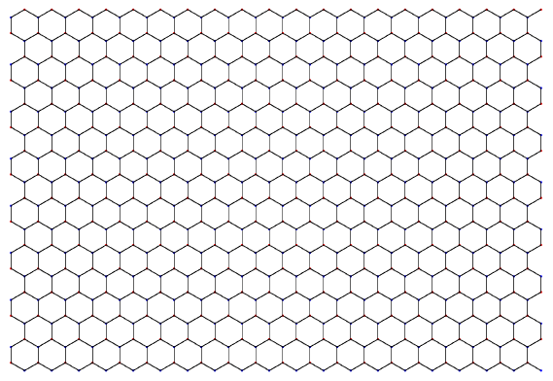

8 Rows

Figure 2 Graphene Nanoribbon with dimensions: 8 Rows and 20 Columns

## Step 2

After the user enters the numbers 8 and 20 inside the suitable frames of the first window, the user clicks on “Create”. This action opens the main window of the program (Figure 3). In MATLAB’s Command Window there are some basic instructions. Initially, just the button “Final Design” is enabled. This button must be selected after the removal of the excess of atoms in order to define the final structure of graphene nanoribbon. The user chooses the atoms to be removed by defining a rectangle whose two points must be selected. These two points are submitted by clicking on the surface of the MATLAB form. The first point is the upper left point and the second one is the bottom right point of the rectangle. So, lets remove the bottom left quarter of the graphene structure in Figure 3. The way to do it is by choosing firstly the upper point, which is depicted in red color in Figure 3, and afterwards the bottom point, which is depicted in blue color in Figure 3. However, it must be noted that these points do not appear during the program execution. Afterwards the new structure appears (in the Console Window the message “Removal Completed” appears) and the user chooses the button “Final Design”. Figure 4 shows the next form.

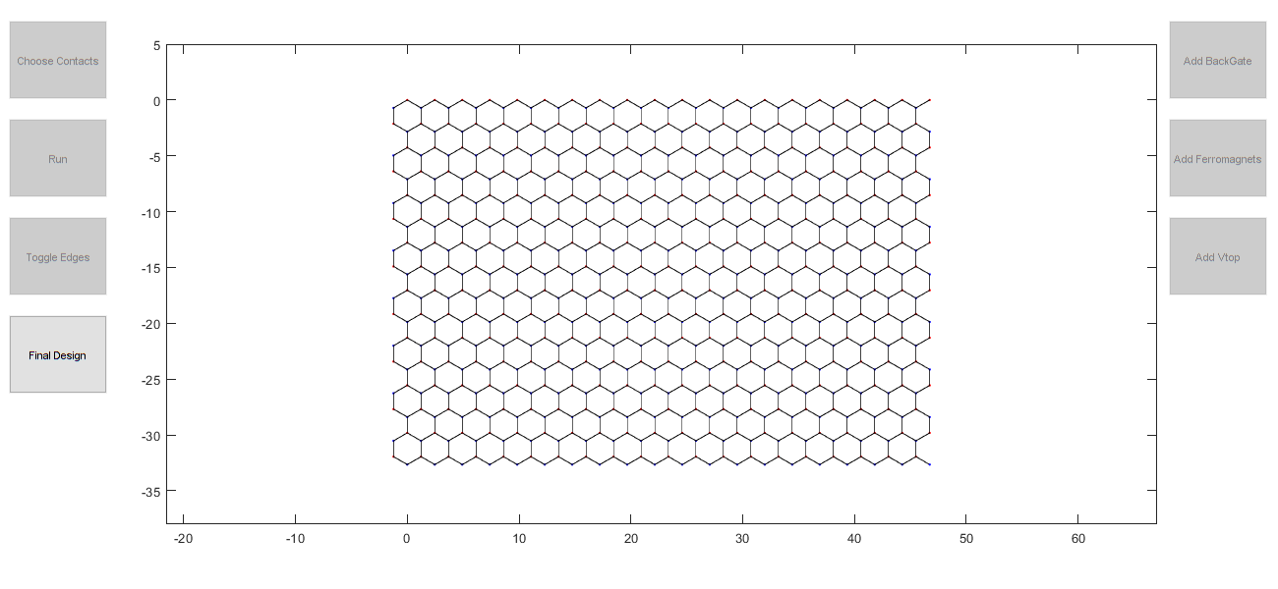

Figure 3 Program's basic Interface

## Step 3

In Figure 4 one can observe that the user can set the gates and then the contacts. The mandatory steps to be followed are described here:

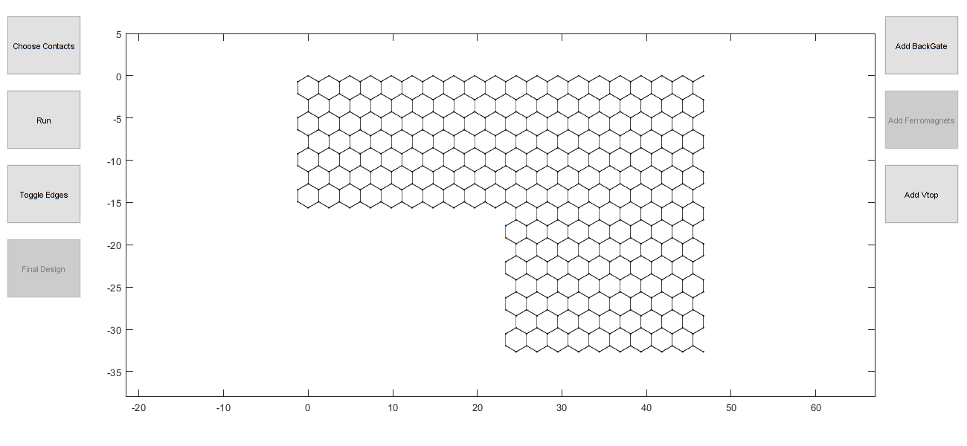

Figure 4 After the removal of the atoms, the buttons to add gates and contacts are enabled

Initially, if it is desirable, the user can place a Back Gate. So, the user chooses the button “Add BackGate”. The appearing window demands the input of the voltage’s magnitude in Volts of the Back Gate. The user inserts the number and presses “Ok”. Afterwards the two points of the rectangle have to be defined. This rectangle must encapsulate the whole surface of the graphene. It is reasonable that just one Back Gate can be placed. Having placed the optional Back Gate, the user can place whichever number of Top Gates is needed. The button to place one top gate is “Add Vtop” and in the appearing window the user types the desirable voltage value. Then, by choosing the two points, the rectangle encloses the group of atoms that are affected by the top gate. By repeating this process, the user can add more Top Gates.

Next, the contacts must be defined. The button to add the contacts is labeled “Choose Contacts”. After pressing the button, the user must define the position of the contact (top or left). For example, if the first contact is placed on the left side, then the electrons will move along the zigzag side of the graphene. To make that clear, the user needs to press the button “Toggle Edges”. In case the user wants to place the contact on the top edge, then the user does not need to press the button “Toggle Edges”. To place the contact i.e., on the left edge, the user should choose again the two points for the imaginary rectangle to encapsulate the first column of atoms of the graphene on the left side (Figure 5). Right after the selection of the second point, the first point of the second contact should be chosen. The second contact could be placed either on the bottom side or on the right side. To choose the side, the user should use the button “Toggle Edges” again. Its value is whichever the selection was for the first contact. This means that, according to Figure 5, if the button is not pressed again, then the second contact is expected to be placed on the right side. Let us place the second contact on the bottom side. So, the user should press the button “Toggle Edges”, and afterwards the user should choose the two rectangle’s points which define the contact. Figure 5 shows the correct definition of the contacts.[1]

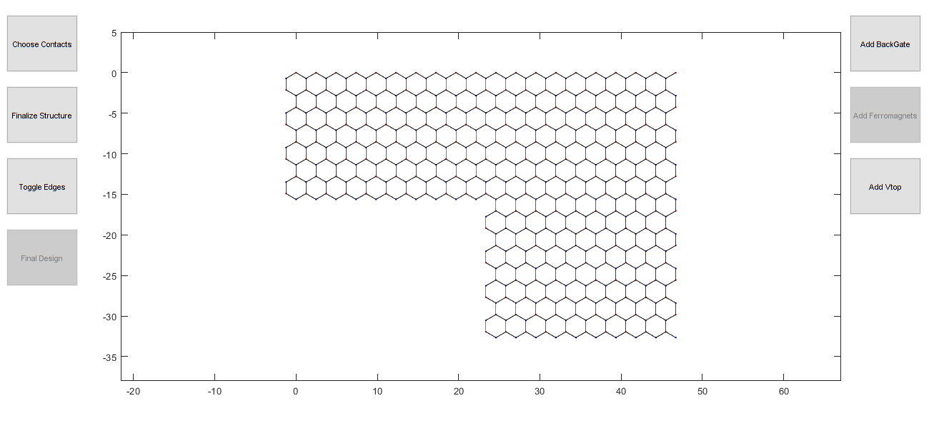

Figure 5 Depiction of the contact's selection points. At first the left contact is defined. The red point precedes the blue one. Then the bottom contact is defined

## Step 4

When the contacts’ placement is complete, the type of the contacts must be defined. Thus, the user must define if the contacts are magnetic. By pressing the button “Add Ferromagnets”, the user defines that the contacts are magnetic and in the new window the magnitude and the angle of the polarization of each contact must be filled. For the program, the vectors of the polarizations are on the surface of the graphene. For this reason, their polar coordinates are in use (Figure 6).

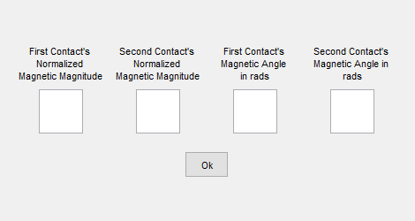

Figure 6 both contact's polarization’s polar coordination input window

After these settings are complete, the simulation can run. This happens by clicking “Run”. Figure 7 demonstrates the relation of the Energy around the Fermi level and the Normalized Conductivity for the simple device of Figure 5 without adding any gates or magnetic contacts.

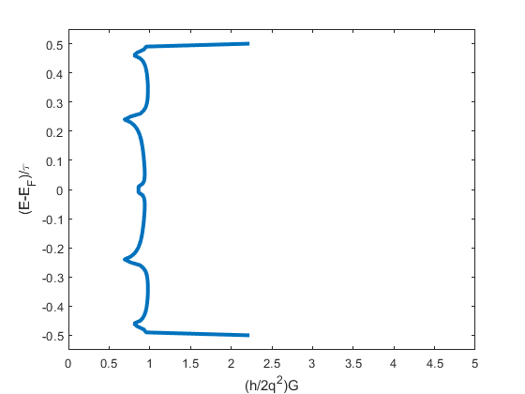

Figure 7 Graph showing the relation of the Energy around the Fermi level and the Normalized Conductivity for the simple device of Figure 5

## Notes

1. Every gate combination, along with or without magnetic contacts, is allowed.
2. Although just one Back Gate can be added, there is not any restriction to the number of Top Gates.
3. The number of atoms participating in the formation of the contacts must be a multiple of 4 for the vertical contact and a multiple of 2 for the horizontal contact.

## Examples

### Nanoribbon with a Back Gate

Let’s simulate a graphene nanoribbon with a Back Gate. According to the general instructions, the file “Graphene.m” has to be executed. In the first window the nanoribbon’s dimensions have to be filled up. Let the dimensions be 10 Rows and 11 Columns. No atom is removed and for this reason the button “Final Design” is immediately pressed (Figure 9). Afterwards, the button “Add BackGate” is pressed and in the appearing window the voltage’s value is put (i.e., 0.5) and then the button labeled “Ok” is pressed (Figure 10). Next, two points (imaginary rectangle) are chosen and the rectangle must encapsulate the whole graphene surface (Figure 11).

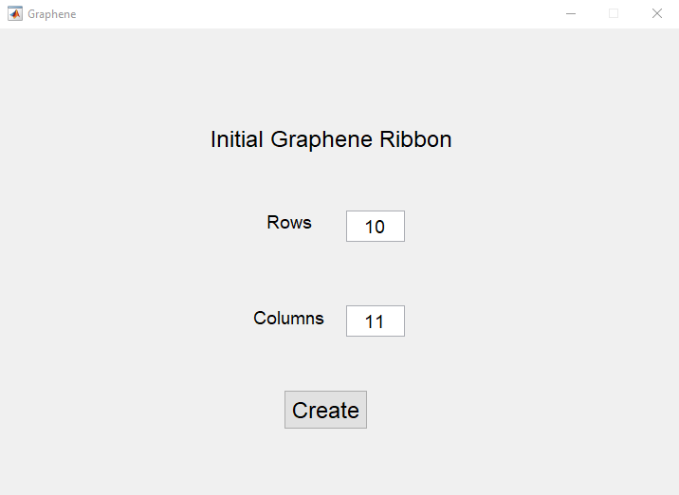

Figure 8 Nanoribbon's dimensions choice

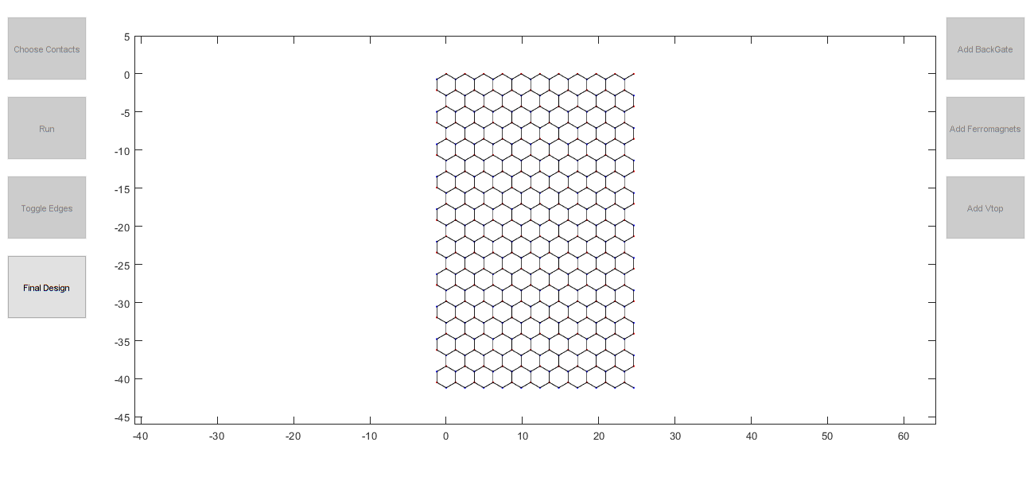

Figure 9 Nanoribbon of example 1

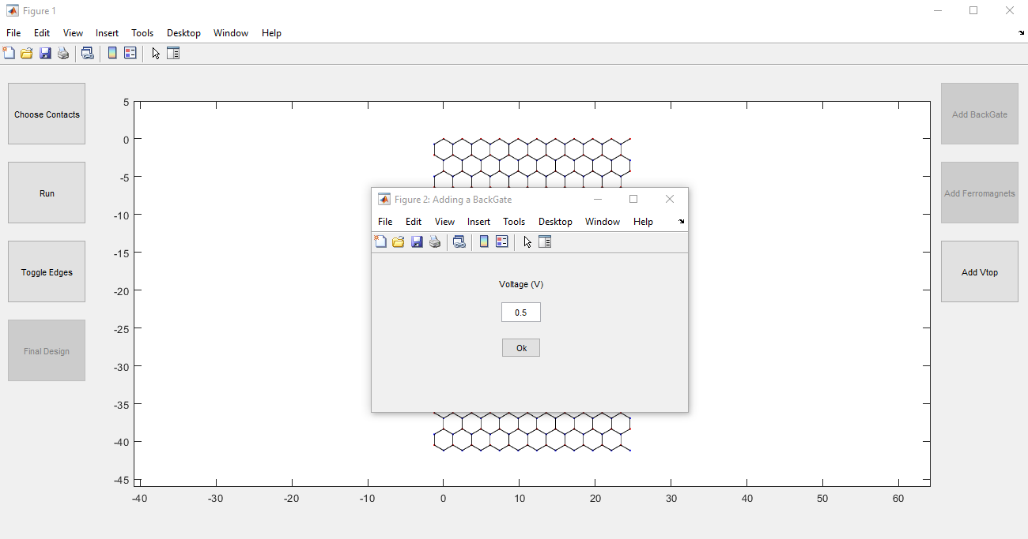

1

3

2

Figure 10 Back Gate's Voltage Definition

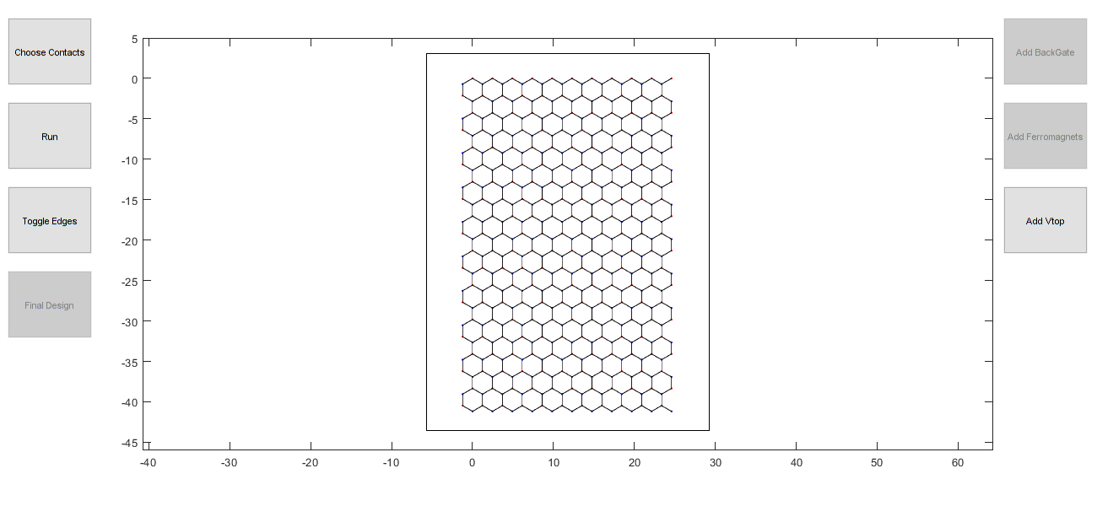

Figure 11 Complete setting

The contacts are left to be added. To complete this task, at first the button “Choose Contacts” is pressed and then, according to the desirable edges, the button “Toggle Edges” is (or is not) pressed and finally the contacts are placed. In this example the armchair edges are chosen (“Toggle Edges” is not pressed). This means that the rectangle of the first contact should encapsulate the atoms of the upper line of the graphene formation and the rectangle of the second contact should encapsulate the atoms of the bottom line of the graphene formation. Magnetic contacts are not set. The result is in Figure 12.

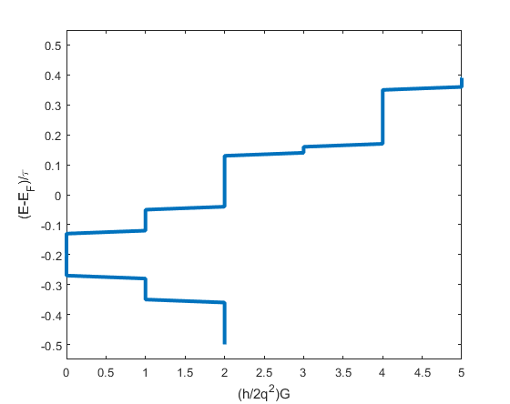

Figure 12 Graph depicting the relation between the Energy around the Fermi level and the Normalized Conductivity of Example 1

## Nanoribbon with Z geometry and one Top Gate

Initially, in order to create the Z geometry, the nanoribbon should lose two specific groups of atoms. Thus, an initial nanoribbon is defined with dimensions 10 Rows and 30 Columns from which the group of atoms are subtracted, as it is depicted in Figure 13.

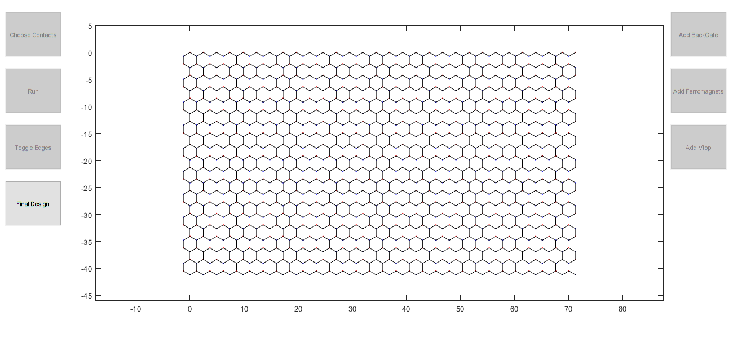

4

3

2

1

5

Figure 13 Initial setting of the example 2. The atoms to be subtracted are displayed and the user's steps-clicks are numbered

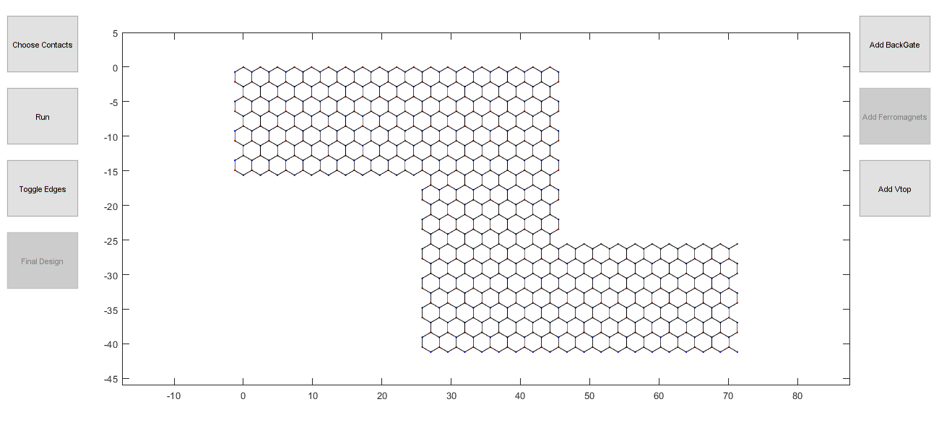

Figure 14 The setting after the atom subtraction in example 2

In Figure 14 where the result of our choices is displayed, we choose the button “Add Vtop” in order to enter the top gate’s voltage (i.e., 0.5 Volt). Let the Top Gate be placed on the middle Columns of the structure (Figure 15).

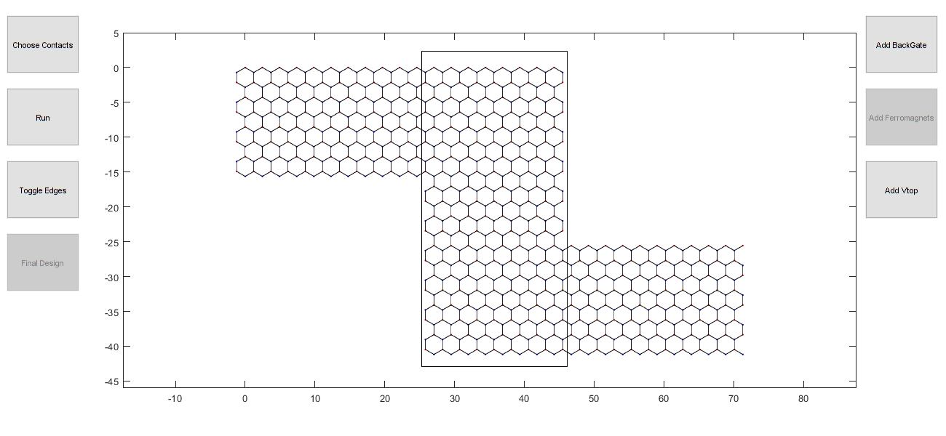

Figure 15 The setting of the nanoribbon after the addition of the top gate on the device in example 2

After this process is done, we need to add the contacts. The type of the edges will be ZigZag and for this reason the contacts will be on the left and right side of the device respectively. We press the buttons in this sequence: “Choose Contacts”, “Toggle Edges” and the placement of the contacts (by clicking) follows. At the end, we press the button “Run”. The result is the graph in Figure 16.

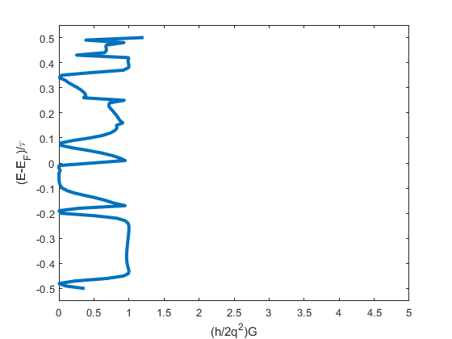

Figure 16 Result of the simulation in example 2

### Nanoribbon with magnetic contacts

This example is about a simple case of magnetic contacts. The nanoribbon is rectangular and the contacts are placed so that the transport is along the Zigzag edges. This means that initially the nanoribbon is defined with dimensions 8 Rows and 4 Columns. Immediately the user chooses “Final Design”. Afterwards not a single gate needs to be added. Thus, the contacts are placed by pressing “Choose Contacts” and “Toggle Edges” and the suitable clicks follow for the points of the imaginary rectangles to be chosen according to the process described previously. Afterwards the button “Add Ferromagnets” should be pressed. Figure 17 depicts the window where the magnetic contacts’ information is entered.



Figure 17 This window accepts the information for the magnetic contacts.

Typically, the Magnitude of the polarization of the contacts is set to 1. The angles, on the other hand, take a value in the range [0,2π] rads. Here we define magnitudes set to 1, the left contact’s magnetic angle set to 0 and the right contact’s magnetic angle set to π/4. The result is depicted in Figure 18.

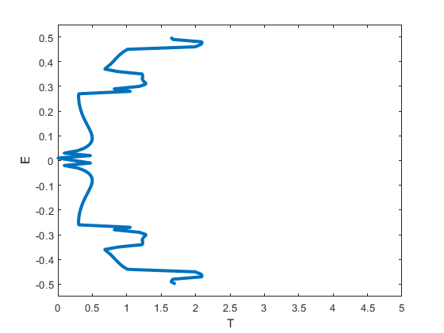

Figure 18 Graph of example 3

1. The geometry of the atoms that can be used to define the contacts is strictly as depicted in Figure 5. That means that the number of atoms used to define the vertical contact has to be a multiple of 4 and the number of atoms used to define the horizontal contact has to be an even number.